## Installation Guide

### Setting up environment at server side

Bellows are requirements for hardware and software environment to run MIC system in 10 years. The specifications are based on the dependencies requirements and performance test result from previous section of this document.

#### Hardware requirements

|  |  |
| --- | --- |
| Hardware | Specification |
| Internet Connection | 8 Mbps |
| Computer Processor | Intel® Core(TM) i5 CPU , M 460 @ 2.53GHz |
| Computer Memory | 3GB of RAM or more |
| Hard Disk Drive | 40GB or more |

Table 1 Hardware requirements

#### Software requirements

|  |  |
| --- | --- |
| Software | Application name / version |
| Operating System | Ubuntu Server 14.04.2 LTS |
| Java | 1.7.0_79 |
| Web Server | Apache Tomcat 7.0.52 |
| Database | MySQL 5.6 |

Table 2 Software requirements

### Web Application Deployment Process

#### Check environment

Check Ubuntu version: 14.04.2 LTS

|  |
| --- |
| root@MIC:~# **lsb_release -a**  No LSB modules are available.  Distributor ID: Ubuntu  Description: Ubuntu 14.04.2 LTS  Release: 14.04  Codename: trusty |

Check Java version: 1.7.0_79

|  |
| --- |
| root@MIC:~# **java -version**  java version "1.7.0_79"  OpenJDK Runtime Environment (IcedTea 2.5.6) (7u79-2.5.6-0ubuntu1.14.04.1)  OpenJDK 64-Bit Server VM (build 24.79-b02, mixed mode) |

Check MySQL version: 5.6

|  |
| --- |
| root@MIC:~# **mysql --version**  mysql Ver 14.14 Distrib 5.6.19, for debian-linux-gnu (x86_64) using EditLine wrapper |

Check Apache Tomcat version: 7.0.52

|  |
| --- |
| root@MIC:~# **/usr/share/tomcat7/bin/version.sh**  Using CATALINA_BASE: /usr/share/tomcat7  Using CATALINA_HOME: /usr/share/tomcat7  Using CATALINA_TMPDIR: /usr/share/tomcat7/temp  Using JRE_HOME: /usr/lib/jvm/java-7-openjdk-amd64  Using CLASSPATH: /usr/share/tomcat7/bin/bootstrap.jar:/usr/share/tomcat7/bin/tomcat-juli.jar  Server version: Apache Tomcat/7.0.52 (Ubuntu)  Server built: Jun 19 2015 08:54:46  Server number: 7.0.52.0  OS Name: Linux  OS Version: 3.13.0-57-generic  Architecture: amd64  JVM Version: 1.7.0_79-b14  JVM Vendor: Oracle Corporation |

#### Import database

Using file **database.sql** located under **Deployment** directory from this document.

|  |
| --- |
| root@MIC:~# **mysql -u root -p mic_data < database.sql** |

#### Build war artifact

Under **Source code/MICWeb** directory, edit file **pom.xml** and set correct MySQL username and password at <**profiles>** tag:

|  |
| --- |
| <profiles>  <profile>  <id>production</id>  <properties>  <db.username>**mysql username here**</db.username>  <db.password>**mysql password here**</db.password>  </properties>  </profile> </profiles> |

Under **Source code/MICWeb** directory, run bellow command to build war artifact:

|  |
| --- |
| **mvn clean install –pProduction** |

A **war** artifact file will be created under **Source code/MICWeb/target** directory, we will use this file for deployment.

#### Deploy war artifact

Using file **war** built from previous step.

|  |
| --- |
| root@MIC:~# **mv MIC.war /var/lib/tomcat7/webapps/ROOT.war** |

Web application is now available at **http://server-ip-address**.

### Mobile Application Deployment Process

At mobile device, go to Setting/Security, uncheck check box **Unknown sources**.

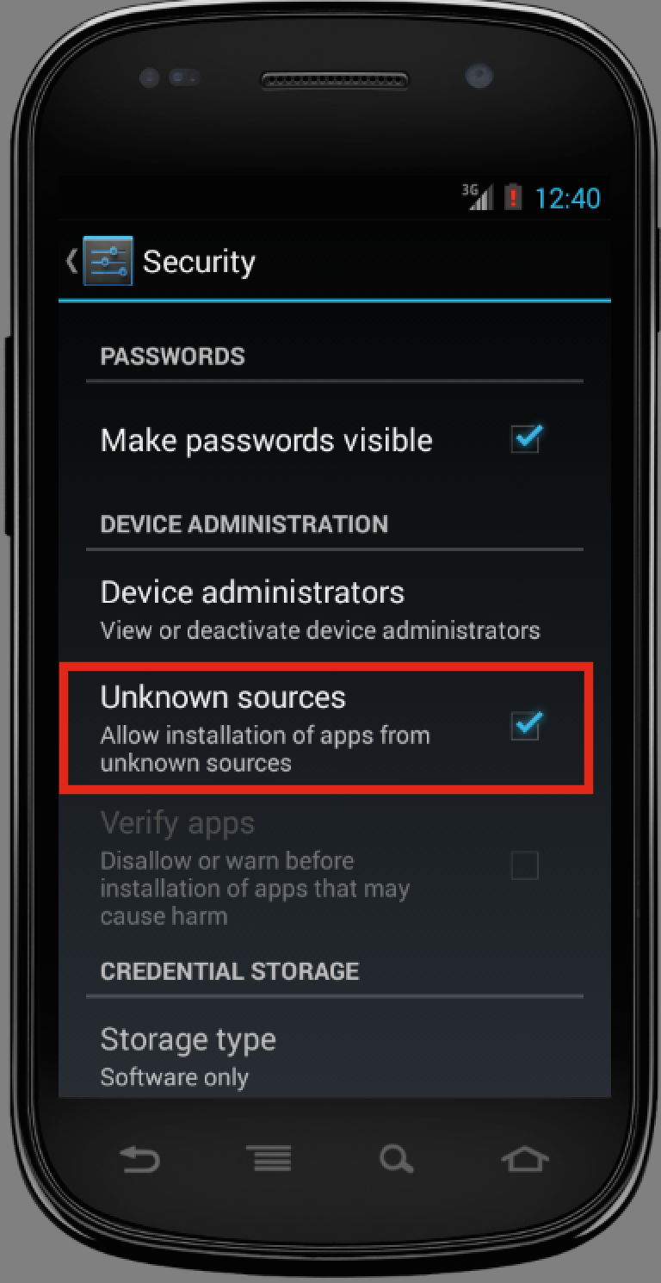

Using apk files from **Deployment** directory under this document. Click to install application.

